Integrated impact assessment (IIA) Template
Complete as a record of your assessment.
Read the IIA guidance before completing this template.

Title of proposal
Review of Working Patterns and Rotas – Learning Disability Service

Purpose of proposed work
The Learning Disability (LD) Service has recently concluded a structural review as part of the Health and Social care Partnerships Organisational Review (phase 2).

Current working arrangements are shaped by a high number of vacancies, high agency use and rota management practices that have evolved inconsistently across teams, with a variety of different working patterns in place across the service. This has resulted in inequitable working patterns and hours, and challenges in ensuring a fair, equitable and sustainable approach. This has also led to inefficiencies and increased staffing costs from the use of supplementary staffing.

A review of working patterns and rotas across the LD Service is proposed with a view to implement a sustainable, equitable and efficient staffing model which enhances the quality and consistency of care and support and promotes colleague wellbeing.

No workforce reductions are proposed within this change. Any changes will be to working patterns, e.g., days and hours scheduled to work. Colleagues in scope work a variety of shifts over a 24-hour period, including nightshift and sleepover arrangements. There is no planned reduction in contractual hours and colleagues will continue to benefit from unsocial hours/ working time payments. Any efficiencies will come from a reduction in supplementary staffing.

Objectives of the Change
- Improve the quality and continuity of care and support across teams
- Ensure staffing arrangements are aligned to the needs of service users, providing person centred support and ensuring positive outcomes
- Support colleague wellbeing through clear and transparent working arrangements
- Establish fair, equitable, and sustainable working patterns across the service and reduce variation in working practices
- Introduce a more co-ordinated and efficient approach to workforce planning and rota management
- Reduce dependence on supplementary staffing and associated expenditure
- Build service resilience and flexibility
- Create a healthier more sustainable and resilient workforce

Lead officer, name, job title, service and department
Stella Morris, Learning Disability Service Manager

Additional colleagues: name, job title, service and department
Emma Pemberton, Change and Development Implementation Manager, Learning Disability Service, Health and Social Care Partnership (Report Writer)
Ashleigh Chambers, Change and Development Implementation Manager, Learning Disability Service, Health and Social Care Partnership
Debbie Finch, Senior HR Consultant, Human Resources, Corporate Services
Danni Burgess, Accountant, Financial Services, Corporate services
Kimberly Swan, Chief Executive, FAIR Ltd
Paul Penrice, Team Leader, Learning Disability Service, Health and Social Care Partnership
Doreen Mutch, Care and Support Supervisor, Learning Disability Service, Health and Social Care Partnership
Monika Blaskiewicz, Care and Support Practitioner, Learning Disability Service, Health and Social Care Partnership
Vhari Boynes, Team Leader, Learning Disability Service, Health and Social Care Partnership
Ben Owen, Staff Representative, Unite the Union
Ian Mullen, Staff Representative, Unison

Date
18th August 2026

Briefly describe public involvement in this proposal to date and planned
There has been no public involvement. This review relates to colleague working arrangements.

Impacts

1 Equality impacts
We want to ensure our proposals are fair for everyone. Consider potential positive and negative impacts of your proposal on groups/people with protected characteristics. Assessment of impact means we consider the needs of everyone with an “intersectional lens.” This means looking at the impact that different protected characteristics and other factors can have on people.
Consider if your proposal will help:
- prevent discrimination
- advance equal opportunities by reducing disadvantage and meeting different needs, and
- foster good relations by encouraging inclusion and understanding.

Consider if your proposal could impact on groups/people with protected characteristics. Tick all that apply
 | Negative impact | Positive impact | No impact
- Age | ✔️ | ✔️
- Disability | ✔️ | ✔️
- Gender reassignment | ✔️ | ✔️
- Marriage and civil partnership |  |  | ✔️
- Pregnancy and maternity | ✔️ | ✔️
- Race | ✔️ | ✔️
- Religion or belief | ✔️ | ✔️
- Sex | ✔️ | ✔️
- Sexual orientation |  |  | ✔️
- Care experienced children and young people | ✔️ | ✔️

Use the text box below to describe the differential impacts you have identified on each of the groups/people with protected characteristics. Consider any intersectional impacts.
Age, disability, Sex
Changes within working patterns and rotas have the potential to both negatively and positively impact colleagues, dependent on colleagues’ individual personal circumstances. This may impact people of any age, particularly those who are in their middle or older years with age associated health conditions. There may be intersectional impacts relating to women or men and associated female or male health related impacts and/ or disability. Additionally, colleagues with unpaid caring responsibilities, which is generally undertaken by a higher percentage of women but may also impact men.

Colleagues have reported dissatisfaction or concerns relating to split days off, too long or too short shifts and too short or too many consecutive days. It has further been reported that this can have a negative impact on recovery time and/ or personal commitments and may contribute to fatigue or poor health and wellbeing outcomes. Establishing fair, equitable, and sustainable working patterns should ensure well planned and structured rota’s with appropriate recovery time. This would have a positive impact on colleagues with a reduction in fatigue and better work life balance. This may have further positive impacts on retention with colleagues remaining in post longer, strengthening our workforce and ensuring continuity of care which is beneficial for service users, unpaid carers and families to build relationships with staff.

Dependent on the proposed rotas it may allow colleagues with health concerns or disabilities to plan and attend appointments at times more appropriate to them. A change in rotas may offer healthier opportunities with more of a work life balance, enabling colleagues to take part in regular non-work related activities, reduce disability related absence and improve attendance.

Change can be perceived as challenging and may be stressful for some people. This could have a negative impact on colleagues, people with a learning disability or unpaid carers/ family members. Any changes in support may take time to understand and clear communications will be required to be developed and in a variety of inclusive / accessible formats.

Colleagues may experience anxiety relating to change which may impact them negatively, particularly where colleagues have ill health or long term conditions, which may in turn increase sickness absence.

Women or men with unpaid caring responsibilities within their personal lives may be positively or negatively impacted depending on review outcomes. Having a structured rota should be beneficial and allow for planning. Any changes without considerable notice would likely result in negative impacts.

For colleagues looking to flexibly retire, a change in working patterns and rota’s may negatively or positively impact their decision to flexibly retire dependent on the configuration of hours and days to allow this and individual circumstances.

Gender Reassignment
Where colleagues may be commencing this process there may be associated appointments which a structured work pattern may have a positive impact for planning appropriate supports.

Pregnancy and Maternity
New parents coming back from maternity may experience positive impacts from a more structured rota as this would allow for planning. This may have a positive impact on any pregnancy, post-natal and early parenthood fatigue or related support requirements. It may also allow better planning for expressing milk where required.

There may be positive or negative impacts relating to shift duration and frequency, dependent on personal circumstances and preference.

Colleagues on maternity leave may not feel involved in the review process and this may not be a priority within their current circumstance. This could negatively impact on colleagues and some may experience anxiety, concern or worry.

Religion or belief
Rota changes may result in positive or negative impacts regarding religious practice, dependent on review outcomes and individual circumstances.

Care experienced Children and Young People
Service users joining the service are mostly care experienced. This period of transition can be challenging. This review will positively impacts service users who will benefit from a structured environment with consistent rota management practices and a reduced number of staff within their private homes at the same time (e.g., handover).

Evidence
Use the text box below to summarise what evidence you have used to inform this IIA. Where possible, include links if the documents are published. Show how you have used your evidence in making your assessment of potential impacts.
Example: A proposal to increase charges will impact women more than men as we know women are more likely to be vulnerable to poverty. The Gendered Nature of Poverty briefing note provides an overview of this issue and why it matters.
Evidence could include the results of any relevant consultation/engagement. If further evidence is required, please note how it will be gathered.
Impacted Roles (correct as of 30/7/26 - please note staffing numbers fluctuate)

There are 268.75 full time equivalent Care and Support Workers (Grade 4) impacted. Of those there are 191 people in post and 90 vacancies.

There are 82 full time equivalent Care and Support Practitioners (Grade 5) impacted. Of those, there are 39 people in post and 43 vacancies.

There are 48 full time equivalent Care and Support Supervisors (Grade 6) impacted. Of those there are 52 people in post and 0 vacancies.

In total there are 282 people in posts who are generally working shifts out with standard office hours.

Colleague Workstyle Survey

The Learning Disability Workstyle Survey (Appendix 1) concluded late 2025/ early 2026 with a 43% return rate and with Care and Support Workers providing the greatest number of responses. This data confirms change is needed with varying views on areas where colleagues are unhappy, supporting the need for this review and seeking further valuable colleague feedback.

Workforce equalities data (determined by colleague completion of this data on employment records):

- 73% of colleagues work full time and 27% work part time
- There are a higher proportion of females to males with approximately 10% difference
- There are an almost equal number of colleagues reporting their ethnicity to be white or ethnic minority.
- There are a small proportion of colleagues reporting a disability (4.1%)
- The highest proportion of colleagues are aged between 30 and 51 and thereafter 51 to 68. There are a very small percentage of colleagues under 22 and over 68.
- Almost half the workforce chose not to confirm a religious belief or not however, of those who did there is a higher number who confirmed a religious belief to those who didn’t.
- Almost half the workforce chose not to confirm their sexual orientation. Of those who did a small number reported their sexual orientation as LGB+
- Just over half the workforce did not provide any information regarding whether they are an Unpaid Carer. Of those who did 7.7% confirmed they are a Carer within their personal lives.

Specific demographic details are provided below:

Women and Men:
Female 54.6%
Male 45.4%

Ethnicity:
Disclosure rate 79.1%
White 40.3%
Minority Ethnic 38.8%
No information provided 20.9%

Disability:
Disclosure Rate 75.5%
Disabled 4.1%
Not Disabled 71.4%
No information 3.6%
Prefer not to say 3.6%

Age:
Under 22 year 0.5%
22 to 30 years 4.1%
31 to 40 years 28.6%
41 to 50 years 28.6%
51 to 60 years 22.4%
61 to 68 years 15.3%
69 years and over 0.5%

Religion or Belief:
Disclosure rate 45.4%
Religious belief 35.7%
No religious belief 9.7%
Prefer not to say 5.1%
No information 49.5%

Sexual Orientation
Disclosure rate 43.9%
LGB+ 2%
Heterosexual or straight 41.8%
Prefer not to say 5.1%
No information 51%

Carer:
Disclosure rate 43.4%
Carer 7.7%
Not a carer 35.7%
Prefer not to say 2.6%
No information 54.1%

Current identified risks:

- Inconsistent rota management practices across teams, leading to duplication, inefficiencies and reduced service oversight
- Inconsistency of working arrangements, increasing the risk of colleague dissatisfaction and grievance
- Limited ability to ensure flexibility across the service due to a lack of standardised planning and processes
- Reduced resilience and flexibility in responding to service requirements
- Increased resource pressures over peak holiday periods, impacting on service quality and continuity
- Increased management time spent addressing rota gaps and issues taking the focus away from service improvement
- Significant and ongoing recruitment and retention challenges, impacting service quality and contributing to workforce fatigue and increased pressure on colleagues (almost 4% leavers noted between March and June)
- Increased reliance on agency staff, leading to reduced continuity of service delivery and higher staffing costs. Agency spend in 2025/26 was £3,872,194.

Mitigation Strategies:
- Recruitment campaigns (significant appointment of Care and Support Workers May/June 2026. Post commencement expected around September)
- Bringing quality and compliance together as one team, including rota co-ordination
- Enhanced training and support for permanent staff as longer term, part of Strategic Workforce Planning

Health and care (Staffing) (Scotland) Act 2019 provides a statutory basis for the provision of appropriate staffing in health and care services, enabling safe and high-quality care and improved outcomes for service users. It builds on existing policies and procedures within both health and care services and effective implementation aims to embed a culture of openness and transparency, ensuring staff are informed about decisions relating to staffing and able to raise concerns and supports the requirement for the right people, in the right place, with the right skills, at the right time.

The Care Inspectorate are the national assurance and improvement support body for social care services and social work in Scotland. Their vision is that everyone in Scotland experiences high-quality, compassionate care, support and learning when they need it, which upholds their rights and choices.

Safe staffing programme in the Care Inspectorate is a quality improvement programme commissioned by Scottish Government. The safe staffing team have been supporting the care sector in relation to the enactment of the Health and Care (Staffing) (Scotland) Act 2019 and they work in collaboration with service providers, people who experience care, relatives’ representative groups and key stakeholders. Their key principles tell us the wellbeing of staff is essential and their views are vital in shaping decisions. They also tell us services must have sufficient numbers and availability of staff with consideration to the overall number of staff in addition to the knowledge, skills, values and experiences of staff to enable high quality care. Staffing levels should include a mix of staff roles, experience, mentors and key workers to meet peoples needs and wishes.

Fairer duty Scotland: Guidance for public bodies as set out in Part 1 of the Equality Act 2010, came into force in Scotland from 1 April 2018. It places a legal responsibility on particular public bodies in Scotland to actively consider (‘pay due regard’ to) how they can reduce inequalities of outcome caused by socio-economic disadvantage, when making strategic decisions.

The Working Time Regulations 1998 establish a legal foundation for maximum weekly hours, breaks, and paid time off, sets limits on working hours, ensuring rest and breaks, typically capping adult work at an average of 48 hours/week (with opt-out), while guaranteeing daily/weekly rest, 20-minute breaks for shifts over 6 hours, and paid annual leave. This is rooted in the European Working Time Directive but now UK law, covering aspects like night work and rest for young workers.

Key Provisions:
- 48-Hour Week: Adults generally cannot work more than 48 hours on average, calculated over a 17-week period, though workers can opt out.
- Rest Breaks:
  - Daily: 11 consecutive hours rest between working days.
  - Weekly: One day off per week, or two days per fortnight.
  - Rest Break (Shift): A 20-minute break if working over 6 hours.
- Night Work: Limits average night work to 8 hours in 24 hours for those regularly working at night.
- Young Workers (Under 18): Stricter limits of 8 hours/day, 40 hours/week, with no averaging.
- Paid Leave: Entitlement to 5.6 weeks of paid annual leave.

Scottish Social Services Council | SSSC are the regulator for the social work, social care and children and young people workforce in Scotland. Their vision is for the people of Scotland can count on services being provided by a trusted, skilled, confident and valued workforce. Colleagues working in registered services are required to register with the SSSC.
Changing Patterns of Work - Acas describes various patterns of working time and indicates their advantages and disadvantages. In particular, it offers information relating to flexible working hours, part-time working, overtime, compressed working weeks and shift work. Changing patterns of work can help to improve efficiency, job satisfaction and motivation and can attract new recruits. Changes to patterns of work should not be considered in isolation and consideration of the effects of any changes on payments systems, work schedules, productivity, staffing, absence levels and employees' terms and conditions of employment should be given.

Managing shift work. Health and safety guidance. HSG256 confirms that research has shown that there can be undesirable consequences for those working shifts outside standard daytime hours, particularly those covering the night or with early morning starts, e.g., shift work may result in: disruption of the internal body clock; fatigue; sleeping difficulties; disturbed appetite and digestion; reliance on sedatives and/or stimulants; social and domestic problems, which in turn can affect performance, increase the likelihood of errors and accidents at work and might have a negative effect on health.

It further highlights that while we cannot change our inbuilt characteristics or halt the ageing process, it is possible to adopt coping strategies, alter behaviour and make lifestyle changes that improve sleep quality, increase alertness and reduce health risks. Appendix 2 within the document offers strategies and practical advice shift workers can use to improve their health and well-being.

Page 20-21 offers guidance relating to shift duration. 8-hour shifts are considered to be the optimum length for sustained and consistent work however, 12-hour shifts are popular as they make the working week shorter and may offer some advantages over 8-hour shifts in terms of sleep, health and well-being. The LD Workstyle survey highlights some colleagues preference for longer shifts and fewer days.
The guidance states that there are few differences in the effects of 8-hour and 12-hour shifts on workers and there are no clear advantages to either system. However, the nature of the work needs to be considered. 8-hour shifts are preferable when work is monotonous, demands concentration or vigilance, is isolated, is safety critical and/or there is exposure to work-related physical or chemical hazards. Longer shifts may increase the risk of fatigue and ill health in vulnerable groups such as older workers and new and expectant mothers. Any advantages of 12-hour shifts in terms of health and well-being are likely to be lost if workers take on overtime or second jobs during their free time. As fewer shift teams are required for a 12-hour than for an 8-hour shift schedule it may be more difficult to arrange cover for illness, holidays, training and overtime. Variable shift lengths can give some of the free time benefits of longer workdays and may be less fatiguing. They are proving an increasingly popular compromise to the 8-hour vs 12-hour debate. Split shifts, where an individual’s daily work is divided into two or more shifts, are unpopular as they lengthen the working day. The risk of fatigue is increased if there is too short a break between shifts to warrant a return home.

The LD Service Workstyle Survey tells us that colleagues generally do not enjoy or benefit from working long stretches. This is supported within the guidance on page 23 where it states, too many consecutive work days can lead to an accumulation of fatigue and increase the risk of fatigue-related problems including ill health, errors and accidents. Sleep loss and fatigue can also build up if there are too many successive night shifts and/or early morning starts.

Please record any mitigating actions for any negative impacts identified, at Section 10 of this template

Human Rights impacts
The Council must act compatibly with Human Rights legislation. Think about what kind of impact the proposal may have on people in terms of Human Rights. Use the text box below to describe which Human Rights Articles are relevant, which groups are affected and what the potential impacts are.

The human rights that are covered by the Act
The Act sets out your human rights in a series of ‘Articles’. Each Article deals with a different right. These are all taken from the ECHR and are commonly known as ‘the Convention Rights’:

- Article 2: Right to life
- Article 3: Freedom from torture and inhuman or degrading treatment
- Article 4: Freedom from slavery and forced labour
- Article 5: Right to liberty and security
- Article 6: Right to a fair trial
- Article 7: No punishment without law
- Article 8: Respect for your private and family life, home and correspondence
- Article 9: Freedom of thought, belief and religion
- Article 10: Freedom of expression
- Article 11: Freedom of assembly and association
- Article 12: Right to marry and start a family
- Article 14: Protection from discrimination in respect of these rights and freedoms
- Protocol 1, Article 1: Right to peaceful enjoyment of your property
- Protocol 1, Article 2: Right to education
- Protocol 1, Article 3: Right to participate in free elections
- Protocol 13, Article 1: Abolition of the death penalty
Service users have a right to peaceful enjoyment of property. There would likely be a positive impact in making sure that not too many staff are within a person’s home at one time, e.g., rota cross over.
Unpaid caring roles can be complex and fragile and there may be multiple services in place to enable the situation to work well for families and unpaid carers. There would likely be a positive impact on colleagues undertaking an unpaid caring role where individual circumstances are taking into account and colleagues private and family life are respected.
Education is important across all roles within the service, especially given Scottish Social Services Council registration requirements which come with qualification conditions. Colleagues will experience positive impacts with the inclusion of protected learning time.

Evidence
Use the text box below to summarise what evidence you have used to inform this IIA. Where possible, include links if the documents are published. Show how you have used your evidence in making your assessment of potential impacts.
Evidence could include the results of any relevant consultation/engagement. If further evidence is required, please note how it will be gathered.
Human Rights Based Approach | Scottish Human Rights Commission Taking a human rights-based approach is about making sure that people's rights are put at the very centre of policies and practices. The PANEL principles are one way of breaking down what this means in practice. These are: Participation, Accountability, Non-Discrimination, Empowerment and Legality.

As above, the Learning Disability Service Workstyle Survey concluded late 2025/ early 2026 with a 43% return rate and with Care and Support Workers providing the greatest number of responses. This data confirms change is needed with varying views on areas where colleagues are unhappy, supporting the need for this review and seeking further valuable colleague feedback.

Further consultation and engagement will be undertaken with colleagues across the Learning Disability Service and will be completed in line with City of Edinburgh Council Managing Change Policy.

Please record any mitigating actions for any negative impacts identified, at Section 10 of this template

Children’s Rights impacts
The Council must act compatibly with Children’s Rights legislation. Think about what kind of impact the proposal may have on children and young people in terms of Children’s Rights. Use the text box below to describe which Children’s Rights Articles are relevant, which groups are affected and what the potential impacts are.
Any change to colleagues working patterns will positively or negatively impact children depending on colleagues own individual circumstances. There may be a need to adjust childcare arrangements. This may be especially challenging where children may be young carers or where there is unpaid carer responsibilities within the household. It will be important to ensure appropriate time is allowed between the end of consultation and the commencement of new working patterns to ensure any alternative arrangements can be made.

Consistent and balanced rota planning will have a positive impact on colleagues work life balance.

Evidence
Use the text box below to summarise what evidence you have used to inform this IIA. Where possible, include links if the documents are published. Show how you have used your evidence in making your assessment of potential impacts.
Evidence could include the results of any relevant consultation/engagement. If further evidence is required, please note how it will be gathered.
How Being A Working Parent Impacts Children | Anita Cleare provides evidence based insight into this topic confirming, ‘In general, as long as children have access to quality childcare, research shows no overall consistent impacts on children resulting from having parents who work. (The exception being where the absence of work creates financial hardships that impact children’s food security, housing and access to health and education).’

Any proposed changes to colleagues current arrangements may have differing impacts on individuals depending on their role, responsibilities, and personal circumstances.

Please record any mitigating actions for any negative impacts identified, at Section 10 of this template

4 Socio-economic disadvantage impacts
The Council has a duty to consider how it can reduce inequalities of outcome caused by socio-economic disadvantage, when making strategic decisions. However, to support the Council’s Business Plan priorities, the Council considers it best practice to consider the potential impact that all relevant proposals may have on people experiencing socio- economic disadvantage and how inequalities of outcome can be reduced.
Consider if your proposal could impact on any of the below groups? Tick all that apply.
 | Negative impact | Positive impact | No impact
Low income – cannot afford to maintain regular payments such as bills, food, clothing | ✔️ | ✔️
Low/no wealth – enough money to meet basic living costs and pay bills but have no savings to deal with unexpected spends and no provision for the future | ✔️ | ✔️
Material deprivation – being unable to access basic goods and services, ie home contents insurance, repair/replace broken electrical goods, warm winter coat | ✔️ | ✔️
Area deprivation (including communities of interest and communities of place) – where you live, where you work, visit or spend a continuous amount of time can all have an impact ie rural areas, accessibility of transport, education and employment impact, people who have experienced homelessness and/or the asylum system, those who share an identity and/or protected characteristic | ✔️ | ✔️
Socio-economic background – disadvantage that can arise from parents’ education, employment and income, social class in other words. | ✔️ | ✔️

Use the text box below to describe the impacts you have identified on each of the groups above, and how you can reduce inequalities of outcome?
There may be both positive and negative impacts across each of these groups, dependent on individual personal and financial circumstances and current shift arrangements. Whilst all impacted colleagues have access to working time payments, the development of a more structured rota will ensure fair, equitable and sustainable working patterns across the service and ensure working time payments are more balanced. Whilst some colleagues may see a decrease in working time payments, others may see an increase. To ensure colleagues understand any financial impact working time payment information will be required alongside the consultation of any rotas.

Any changes to the number or pattern of working days across the week may have different impacts for colleagues, depending on their current working arrangements. While some may benefit from change, others may experience challenges, including increased travel time and associated travel costs.

A more structure and predictable rota may provide benefits for colleagues by enabling greater certainty when planning shifts and managing personal commitments, e.g., organising childcare, travel and other financial commitments in advance.

For colleagues with unpaid carer responsibilities or financial pressures, changes to working patterns may have a greater impact, particularly given the unpredictable nature of caring responsibilities.

Evidence
Use the text box below to summarise what evidence you have used to inform this IIA. Where possible, include links if the documents are published. Show how you have used your evidence in making your assessment of potential impacts.
Evidence could include the results of any relevant consultation/engagement. If further evidence is required, please note how it will be gathered.
Edinburgh Poverty Commission - Poverty Commission Edinburgh states, ‘Edinburgh will only succeed in creating a prosperous city without poverty if it creates the conditions for good jobs, genuinely affordable housing, income security and meaningful opportunities that drive justice and boost prospects.

Working time payments – The City of Edinburgh Council Intranet are available to:
- Any individual whose regular work pattern requires them to provide a service outside of the normal working hours - 7.00am to 9.00pm.
- Part time staff can claim unsocial hours payments, where applicable, in addition to any additional hours worked up to the equivalent working week of 36 hours.

They are not available to full time employees working overtime, this includes weekend hours or night hours when claiming overtime.

There are two types of working time payments, both will be paid at the same time if you're eligible for them
- Disruption
- Unsocial hours.

Any change in rota patterns may result in financial changes dependent on any changes with working time payments. This may impact male or female colleagues, although as previously noted the service has a higher proportion of female colleagues.

Current workforce data on working time payments:
This data shows the average monthly payments by job role and element of working time payment made. It shows that Care and Support Workers and Practitioners gerarally receive similar average working time payments monthly (around £200 and Supervisors are less with a monthly average of £157.
Please note that average payment are only based on those who receive the payment, not the average counting everyone in the service.

Care and Support Worker:

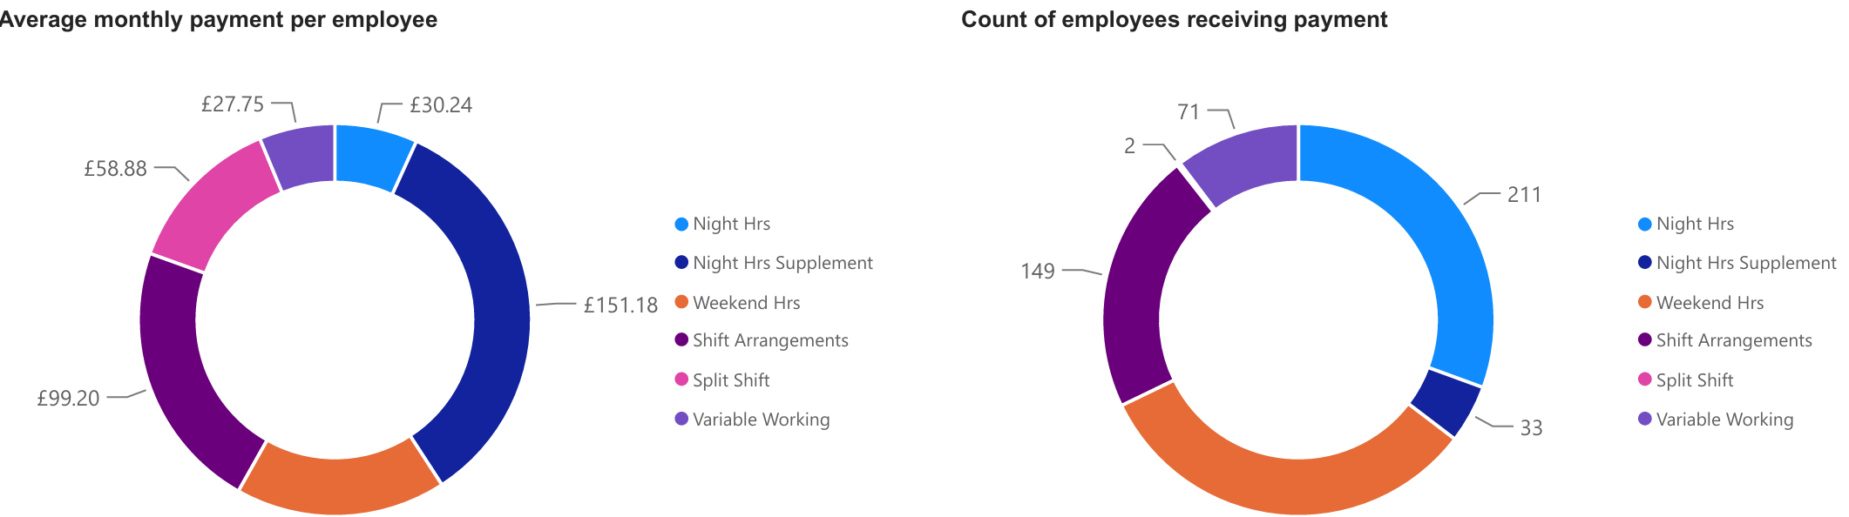

------------------------------------------------------------------------------------------------------------------------

Care and Support Practitioner:

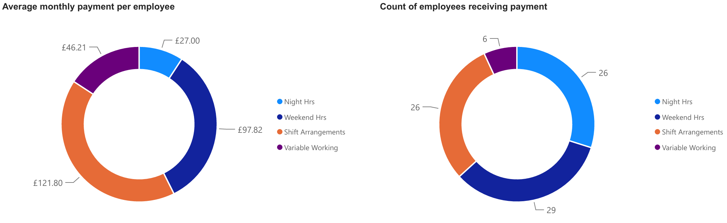

------------------------------------------------------------------------------------------------------------------------

Care and Support Supervisor:

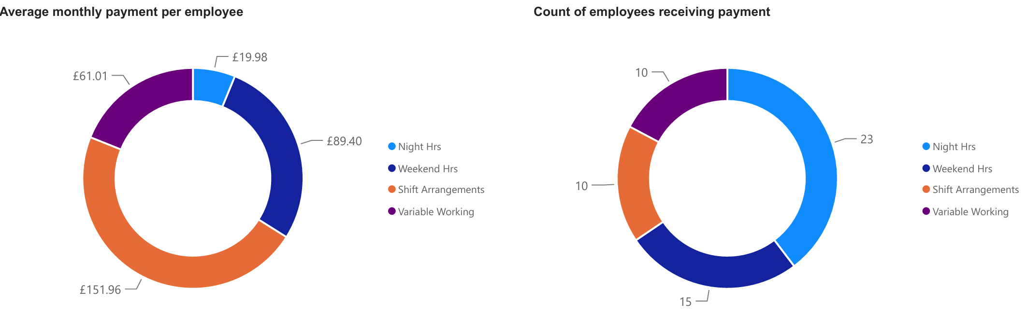

Sleepover Arrangements
This data shows sleepover arrangements by role grade between Oct 2024 and July 2026. Care and Support Workers (Gr 4) receive the highest volume of sleepovers. There are 31 sleepovers each day of 9hrs each, totalling 279hrs per day.

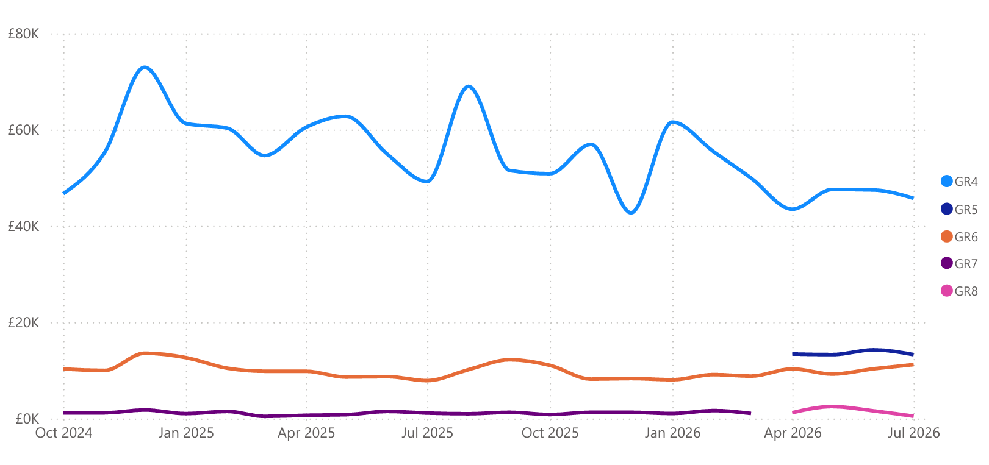

Unpaid-carer-experiences-in-Edinburgh-Interactive-June-2024.pdf highlights that one in seven workers in the UK juggle paid work while caring for an older, disabled or ill person… and many carers will have to give up paid employment altogether in order to provide care.” The role of an unpaid carer often comes with a financial burden, and for those in work, there are significant impacts on employment. Scotland's Carers update release: June 2026 - gov.scot confirms that women are more likely to provide unpaid care than men, and the proportion of the population providing care peaks between the ages of 55 and 64 (20% of men, 27% of women). We know from our workforce equalities data that there are a higher number of female colleagues (55%) than males (45%) and 7.7% of our workforce confirm they are providing unpaid care.

Please record any mitigating actions for any negative impacts identified, at Section 10 of this template.

Climate and nature impacts
The Council has a duty to reduce greenhouse gas emissions, adapt to the impacts of climate change, incorporate the principles of sustainability into decisions and actions, and ensure a just transition (just transition only applies to climate mitigation or adaption projects).
Consider if your proposal could impact on any of the below? Tick all that apply.
 | Negative impact | Positive impact | No impact
Climate Mitigation - opportunities to reduce greenhouse gas emissions | ✔️ | ✔️
Climate Adaptation - opportunities to prepare for future changes in our climate |  |  | ✔️
Just Transition – opportunities to ensure a fair shift to a low carbon economy that doesn’t disadvantage people or increase inequality |  |  | ✔️
Nature Recovery Impacts |  |  | ✔️
Overall Sustainability |  |  | ✔️

Use the text box below to describe the impacts you have identified on each of the sections above and then consider how you can reduce greenhouse gas emissions, adapt to the impacts of climate change, incorporate the principles of sustainability into decisions and actions, and ensure a just transition. Also consider any cumulative effects of climate change on people.
An increase in the number of journeys to and from work each week, particularly where colleagues drive could increase overall travel related emissions. However, there may also be positive impacts from a more structured and predictable rota may enable colleagues to plan ahead and use lower carbon travel options, e.g., walking, cycling, public transport, where practical and accessible.

Use the text box below to describe the impacts you have identified on nature.
None

Evidence
Use the text box below to summarise what evidence you have used to inform this IIA. Where possible, include links if the documents are published. Show how you have used your evidence in making your assessment of potential impacts.
Evidence could include the results of any relevant consultation/engagement. If further evidence is required, please note how it will be gathered.
N/A

Please record any mitigating actions for any negative impacts identified, at Section 10 of this template

Strategic Environment Assessment (SEA)
Could your proposal result in significant environmental effects? If yes, you may need to complete a Strategic Environment Assessment? Information is available on the Scottish Government SEA website.
Yes | No

Consumer Duty
The Council has a duty to consider consumers’ interests when making strategic decisions. If this applies to your proposal, you may need to complete a consumer duty impact assessment. Information is available on the Consumer Scotland website.
Yes | No

Communications
Record how you will communicate information about this proposal change to those with different communication needs using inclusive communications guidance and resources.
Communications will generally be made to colleagues via email with information being presented in person and/or on Microsoft Teams. Individual 1;1 meetings will take place with line managers and additional meetings/ discussions can be arranged where necessary. For any colleagues with specific requirements, e.g., large print or additional discussions, this will be arranged.

Contractors
Is any part of this proposal to be carried out wholly or partly by contractors and if so, how will equality, human rights, children’s rights and climate and nature issues be addressed?
This proposal will not be carried out wholly or partly by contractors.

Actions
Record your actions in the table below. Actions may include:

Actions | Who will take them forward (name and job title) | Deadline for progressing | Review date  (add name and job title)
Ensure ongoing communication and sharing of information throughout engagement and consultation with colleagues | Stella Morris  Service Manager | Ongoing | Throughout  Emma Pemberton  Change & Development Manager
Ensure appropriate individual communications with service users and unpaid carers/ families | Care and Support Team Leaders | Ongoing | Throughout  Emma Pemberton  Change & Development Manager
1;1 conversations with line managers to discuss any individual impacts and application of appropriate CEC Policies | All line Managers | Ongoing | Throughout  Emma Pemberton  Change & Development Manager
Review any individual service user impacts and consider mitigations | Care and Support Team Leaders | Dec 2026 | Dec 2026  Emma Pemberton  Change & Development Manager
Ensure colleagues currently absent (e.g., sickness, maternity) are included throughout review | Care and Support Team Leaders | Ongoing | Throughout  Emma Pemberton  Change & Development Manager
Completion of working time payment forms for any proposed rotas to enable understanding of any individual financial impacts | Ashleigh Chambers  Change and Development Manager  Stuart Miller  Care and Support Group Manager | Oct 2026 | Oct 2026  Emma Pemberton  Change & Development Manager
Plan for appropriate time between end of consultation and start of new rotas to enable colleagues to plan accordingly | Emma Pemberton Change & Development Manager | Oct 2026 | Oct 2026  Emma Pemberton  Change & Development Manager

Monitoring impact
Monitoring ensures that your proposal is effective and any issues are addressed.
Record your actions in the table below. Actions may include:
- how impacts on protected characteristics will be monitored, once the proposal has been introduced and implemented
- how IIA agreed actions will be monitored
- review process and timescales
- officer responsible.

Actions to monitor impact of proposal | Who will take them forward (name and job title | Deadline for progressing | Review date  (add name and job title)
Review IIA Actions | Emma Pemberton  Change and Development Manager | Ongoing in line with individual deadlines and review dates | July 2027  Emma Pemberton  Change and Development Manager
Oversight of any individual and collective impacts and ongoing 1;1 | Stella Morris  Service Manager | July 2027 | July 2027  Emma Pemberton  Change and Development Manager
Evaluation of outcomes through colleague questionnaire | Emma Pemberton  Change and Development Manager | July 2027 | July 2027  Emma Pemberton  Change and Development Manager

Next steps
Elected members must have access to IIAs in order to scrutinise them before making decisions. You must:
- share the IIA with them (this can be at draft stage for an APM meeting)
- complete the committee report with:
  - a summary of the identified impacts at section 7 of the committee report template: key policies
  - actions to address them at section 5 of the committee report template: next steps
- provide a link to the published IIA or attach as an appendix.

Committee approval not required for this proposal.

Quality assurance and approval
Complete the quality assurance checklist.
Send the quality assurance checklist and your completed IIA to your Head of Service for approval.

Authorisation
Name and title
Anna Duff, Head of Service – Substance Use, Mental Health & Learning Disability
Date
26/08/2026

Publication
Send the approved IIA template to the relevant contact for publication. Ensure the title of the IIA is clear and concise, without acronyms and the content, layout and language style is inclusive and accessible.
The City of Edinburgh Council:
- integratedimpactassessments@edinburgh.gov.uk to be published on the Council website
Edinburgh Integration Joint Board/Health and Social Care:

sarah.bryson@edinburgh.gov.uk to be published on the EH&SCP website

Keep a copy of your template for a period of at least three years (longer if needed for business reasons).

